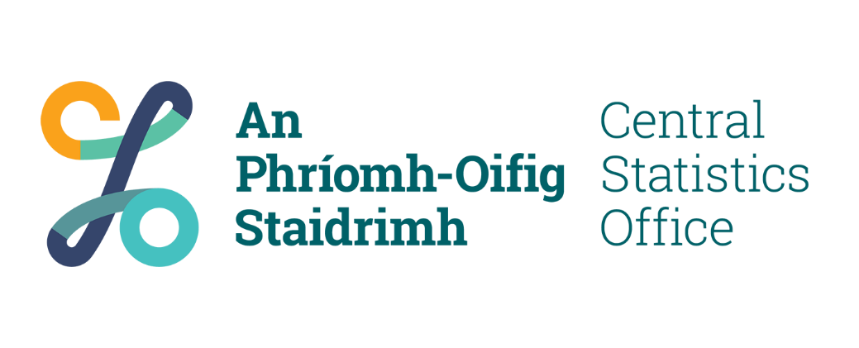
Candidate Privacy Statement

Who we are:
The Central Statistics Office (CSO) is Ireland's National Statistical Institute. Our purpose is to impartially collect, analyse and make available statistics about Ireland’s people, society and economy.
Specifically, our mandate under the Statistics Act, 1993 is "The collection, compilation, extraction and dissemination for statistical purposes of information relating to economic, social and general activities and conditions in the State".
At national level, CSO Official Statistics inform decision making across a range of areas including construction, health, welfare, the environment, and the economy. At European level, they provide an accurate picture of Ireland’s economic and social performance and enable comparisons between Ireland and other countries.
The CSO is also responsible for coordinating the Official Statistics of other public authorities.

Purpose of processing:
The CSO is the controller for data collected to process applications for appointment to positions with this Office. We respect your rights to privacy and to the protection of your personal data (‘Data’). Protecting your confidentiality is at the heart of everything we do as an organisation.

Legal basis for collection and processing:
Your data will be managed in accordance with the General Data Protection Regulation (GDPR), the Data Protection Act, 2018, and all other relevant legislation. Consent underpins our use of your data. Your participation in a competition is entirely voluntary. This means that you can withdraw from a competition at any time.

Categories of data:
Your data will be Data is collected for competitions run by the CSO in order to process your application. This information is used by the relevant recruitment unit to run a recruitment and selection competition from application up to appointment, if you are successful.
The data is collected primarily by means of an application form on the Oleeo platform. This is used to:
- assess your eligibility for a particular competition;
- determine your preferences in relation to the location (if applicable);
- determine whether you meet the shortlisting criteria (if applicable), and;
- to aid the selection board in the interview / assessment situation (if you are called to this stage).
Information you will provide as part of the application process includes relevant qualifications, experience, and examples of the competencies required for the particular post. It also includes your name, address, contact details, and date of birth; (which will not be shared with selection board members).
Other data collected is required to confirm that you meet the essential requirements for the competition, for background checks conducted at clearance and assignment stages to ensure you are suitable for appointment in respect of character, and to establish that you are fully competent to undertake, and fully capable of undertaking, the duties attached to the position. Data collected at the clearance and assignment stages will support security checks and / or Garda vetting, checking of employment or other references, and completion of a health and character declaration. We may also collect copies of relevant qualifications, proof of identification, driver’s licence (if essential), and reports from the Chief Medical Officer (if required).
You may also be asked to provide equality monitoring information on a voluntary basis; this is used to ensure that our assessment processes are fair to all groups covered by Equality legislation.
The CSO only keeps data for purposes which are specific, lawful, and clearly stated. Data will only be processed in a manner compatible with the stated purpose and information collected from you will only be used in order to process your application for, and where successful appointment from, a specified competition.

Who uses data:
Within the CSO, your data will be used by designated Human Resources staff members to support your progression through the application process. It will also be provided to selection board members (if required).
In strictly limited circumstances, the CSO may disclose specific data to external recipients. Examples of legitimate disclosures specific to this Office are listed below:
- Material is provided to the Chief State Solicitor and any of their legal advisers, and to the Workplace Relations Commission (or other appropriate body) as required in the event of a case being taken against the CSO;
- Where a candidate requests a review by the Commission for Public Service Appointments in relation to an alleged breach of the Code, or appeals a decision under the Freedom of Information Act to the Information Commissioner, the information requested by these bodies is provided to them in order for them to respond to the candidate’s request for a review;
- The CSO use external selection board members / assessors / invigilators and these board members / assessors / invigilators may receive, or have access to, candidate application data in order to assist in the determination of suitability for a specific role; selection board members / assessors / invigilators have a duty to keep such information confidential and secure;
- Information may be provided to the Office of the Chief Medical Officer for the Civil Service (CMO) where the CSO requires a pre-employment health check (as the CMO provides the occupational health service for the CSO.

How long will data be retained:
The CSO retains data in accordance with the framework suggested by the National Archives. This framework sets out the retention period for all items of data retained. Competition files and interview board will be retained for 30 years following a competition’s conclusion. At the end of this period, the CSO will transfer the data to the National Archives under the relevant provisions of the National Archives Act, 1986.

What data rights do you have:
The GDPR confers the following rights on individuals:
- The right to be informed
- The right of access
- The right to rectification
- The right to erasure
- The right to restrict processing
- The right to object to processing of data
If you wish to exercise your data rights, please contact the CSO’s Data Protection Officer using the details below.

Further information contact details:
For further information regarding CSO recruitment, please contact Caitriona O’Leary, Assistant Principal Officer, HR – Recruitment & Selection:
- By post: Central Statistics Office, Skehard Road, Cork, T12 X00E
- By phone: 021 453 5620.
- By email: caitriona.oleary@cso.ie.

Data Protection Officer contact details:
The CSO’s Data Protection Officer may be contacted:
- By post: Central Statistics Office, Skehard Road, Cork, T12 X00E.
- By phone: 021 453 5000.
- By email: dpo@cso.ie

Right to lodge a complaint with the supervisory authority:
Under the GDPR, you have a right to lodge a complaint with the Data Protection Commission if you consider that processing of your data is contrary to data protection law. The contact details of the Commission are:
- By post: Data Protection Commission, 21 Fitzwilliam Square South, Dublin 2, D02 RD28.
- By phone: 01 765 0100 / 1800 437 737.
- Online: dataprotection.ie.

